Circuit Analysis (Lab # 2)
Experiment 2: Measurements of Waveforms and Fundamental Quantities, Basic resistive circuits.

Name: ABEERA (2025-CE-66) Registration No: 2025-CE-66

Date: 16-2026-03 Grade and Signature: ………………………

CLO3 | Make measurements in their own constructed electric circuits.
Psychomotor/Affective | Level1  (1) | Level2 (2-3) | Level3 (4-5) | Level4 (6-7)
Report Marks (3) |  |  | Total marks  (10)
_______________________________________________________________________________
_
Objectives: This experiment will provide exposure to measurements of waveforms and Fundamental Quantities, Basic resistive circuits. A primary purpose of this lab course is for you to master the use of electronic test equipment and measurement of fundamental quantities.
Equipment required:
Power Supply, Breadboard, Oscilloscope, Signal Generator Connecting wires, Resistances, Multimeter. Procedure

Experiment # 1
SIGNAL GENERATOR AND OSCILLOSCOPE
- Use the signal generator and the oscilloscope to perform the following tasks.
- Build circuit ‘A’ shown below in Figure 1.
- Set the signal generator to generate a sinusoidal signal with a frequency of 100 Hz and peak-to peak voltage of 5V.
- Set up one probe across input signal, and another across R1 and R2 alternatively.
- Measure and draw all the voltages and time related parameters on the graphs below.

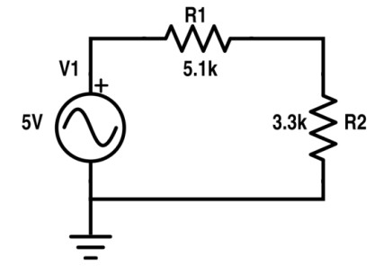
Figure 1 Circuit ‘A’

Resistor | Input voltage | RMS Voltage | P-P Voltage
R1 | 5.0 | 1.074 | 3.036
R2 | 5.0 | 0.69 | 1.96

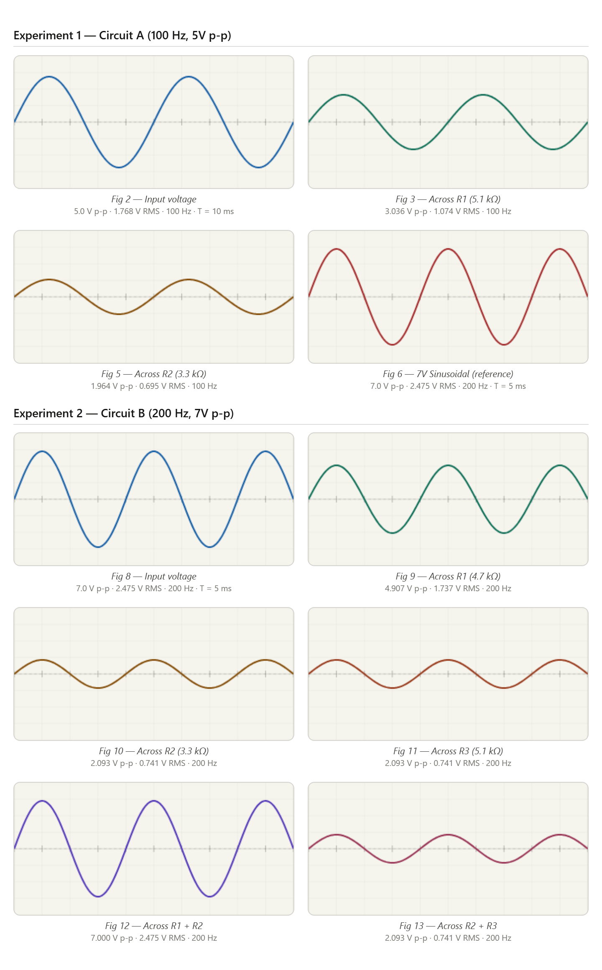

Figure 2 Input Voltage Signal Figure 3 Voltage Signal across R1

Figure 5 Voltage Signal across R2 | Figure 6 Draw 7V Sinusoidal

Experiment # 2
SIGNAL GENERATOR AND OSCILLOSCOPE
- Use the signal generator and the oscilloscope to perform the following tasks.
- Build circuit ‘B’ shown below in Figure 7.
- Set the signal generator to generate a sinusoidal signal with a frequency of 200 Hz and peak-to peak voltage of 7V.
- Set up one probe across input signal, and another across R1, R2 and R3 alternatively.
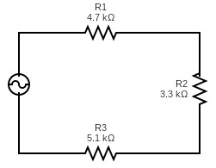
- Measure and draw all the voltages and time related parameters on the graphs below.

Resistor | Input Voltage (V p-p) | RMS Voltage (V) | P-P Voltage (V)
R1 | 7.0 | 1.737 | 4.907
R2 | 7.0 | 0.741 | 2.093
R3 | 7.0 | 0.741 | 2.093
R1 and R2 | 7.0 | 2.475 | 7.000
R2 and R3 | 7.0 | 0.741 | 2.093

Post Lab Questions
- Define Ohm’s law.
Ohm's Law states that the current (I) flowing through a conductor between two points is directly proportional to the voltage (V) across the two points, and inversely proportional to the resistance (R) of the conductor, provided temperature and other physical conditions remain constant. Mathematically: V = I × R.
- What is resistor?
A resistor is a passive two-terminal electrical component that limits or regulates the flow of current in a circuit. It introduces electrical resistance, dissipating energy as heat according to Joule's law (P= I²R).Resistors are manufactured in fixed and variable types, with values measured in ohms (Ω)
- How resistor works?
A resistor works by opposing the flow of electrons through its material. The resistive material (typically carbon film, metal film, or wire wound) has atoms that collide with moving electrons, slowing them down and converting electrical energy into heat (thermal energy). The degree of opposition is determined by the material's resistivity, length, and cross-sectional area. In a circuit, a higher resistance means less current flows for the same applied voltage.

- What is your inference from the input and output waveforms on oscilloscope?
The waveforms confirm voltage divider action in series resistive circuits. The output waveforms across each resistor are sinusoidal and in-phase with the input signal — no phase shift occurs in purely resistive circuits. The amplitude across each resistor is proportional to its resistance relative to the total resistance. In Circuit A, V_R1 > V_R2 because R1 (5.1kΩ) > R2 (3.3kΩ). The sum of V_R1 + V_R2 equals the input voltage at all times, confirming KVL. In Circuit B, R2 and R3 being in parallel receive the same reduced voltage, while R1 drops most of the supply.
- Show calculations of 7V input signal (Figure 10) from signal generator.
  - Voltage calculations (Following volt/dev and number of boxes of oscilloscope)
  - Frequency/Period calculations (Following Steps in frequency measurements section)
  - Current calculation (Ohm Law)
voltage calculations (volts/div on oscilloscope):
If volts/div = 1 V/div → peak = 3.5 divisions → p-p = 7 divisions = 7.0 V p-p
V_peak = V_pp / 2 = 3.5 V | V_RMS = V_peak / √2 = 3.5 / 1.414 ≈ 2.475 V

b) Frequency/Period calculations (time/div):
If time/div =
1 ms/div → one full cycle spans 5 divisions
Period T =
5 div × 1 = 5 | Frequency f = 1/T = 1/0.005 = 200 Hz

c) Current calculation using Ohm's Law:
R_total =
R1 + (R2∥R3) = 4700 + 2004 = 6704 Ω
I_peak =
V_peak / R_total =
3.5 V / 6704 Ω ≈ 0.522 mA
I_RMS = V_RMS / R_total =
2.475 V / 6704 Ω ≈ 0.369 mA
Power dissipated: P = V_RMS² / R_total =
(2.475)² / 6704 ≈ 0.914 mW

